**NAME: FATIMA JAMEEL**

**ARIDNO: 21-ARID-412**

**SECTION: 6 (A) MORNING**

**SUBMITTED TO : SIR AZHAR**

**ASSIGNMENT #2**

**Design screen layouts with static data.**

**XML CODE:**

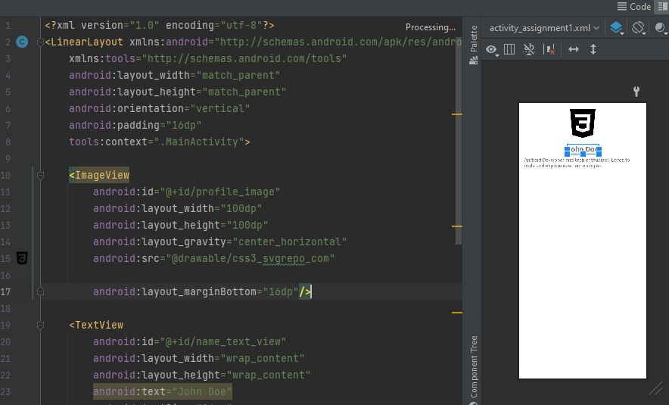

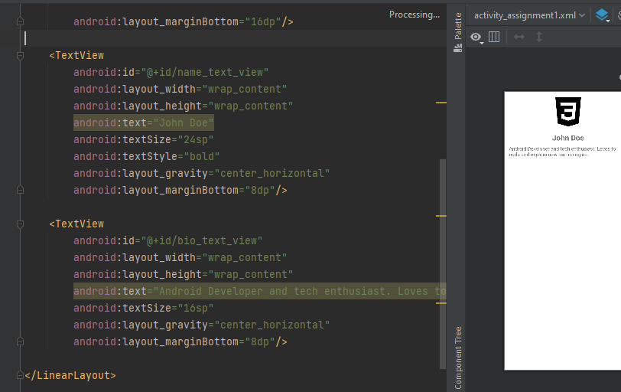

**JAVA CODE:**

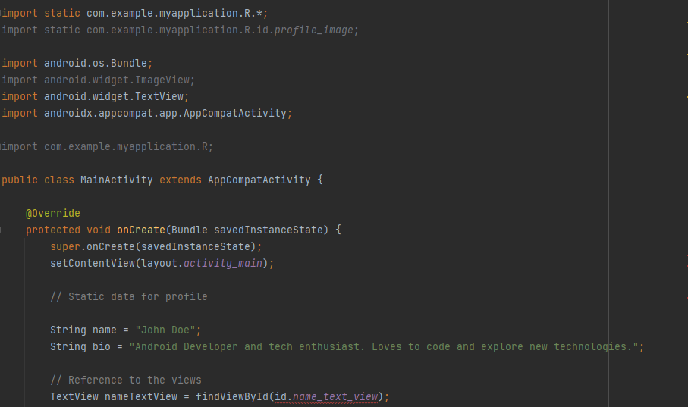

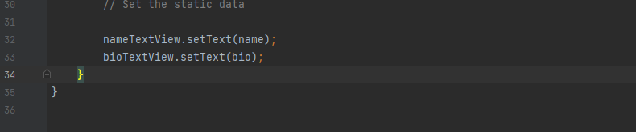

**Dependencies and Libraries:**

The dependencies and libraries required are quite minimal since we're only displaying static data and using basic UI components. Here are the essential dependencies:

1. **AppCompat:** For backward compatibility of newer Android features.
2. **Material Design Library:** For using Material Design components (optional but recommended).
3. **ConstraintLayout:** For flexible layout design (optional based on the layout you choose).

dependencies {

implementation 'androidx.appcompat:appcompat:1.6.1'

implementation 'com.google.android.material:material:1.9.0'

testImplementation 'junit:junit:4.13.2'

androidTestImplementation 'androidx.test.ext:junit:1.1.5'

androidTestImplementation 'androidx.test.espresso:espresso-core:3.5.1' }